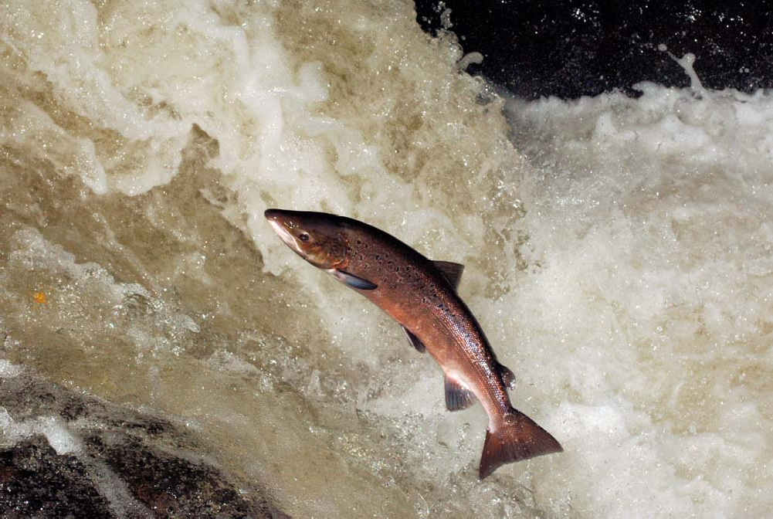

2a Locations in the life cycle of the salmon for ordering
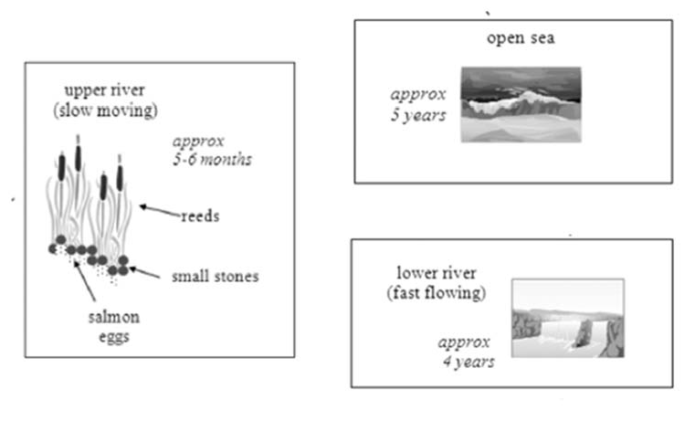

2b Stages of the salmon for matching
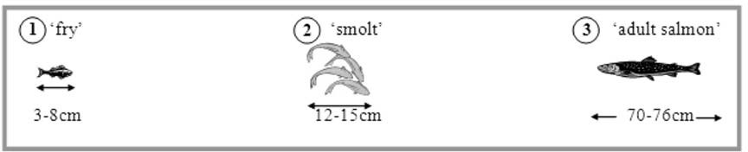

Transition signals of chronological order (time markers)

Subordinating conjunctions | Adverbs | Other (adjectives, prepositions, verbs)
after  as, just as as long as as soon as by the time before since  until when while | first, first of all second, third, etc. last, last of all meanwhile  in the meantime at this/that time  afterwards, after that then  subsequently previously | the first… the second… the third… the next…. another… the last… the final…  before  during after
begin start finish
end (up)

Model answer for completing

Complete the gaps in the text below with an appropriate word or short phrase:

Salmon life as eggs on a pebbly riverbed, hidden among reeds in the slow‐moving upper reaches of a river. five to six months the eggs hatch into 'fry'. For approximately four years, these baby salmon will live in the lower, faster‐flowing waters of their river.
this time they measure between three and eight centimetres in length.
the salmon reach twelve to fifteen centimetres, they are termed 'smolt', and they migrate further downriver into the open sea. five years at sea the salmon will have grown to adult size, which is between seventy and seventy‐six centimetres.
They begin swimming back to their birthplace, where they will lay their eggs, and the cycle starts anew.
In summary, the salmon passes through three distinct physical stages as it grows to maturity. Each of these stages takes place in a very different aquatic location. It is noteworthy that two stages of this fish's life occur in a freshwater environment, while _ stage is lived in saltwater.

WRITING

WRITING TASK 1

You should spend about 20 minutes on this task.
The diagrams below show the life cycle of a species of large fish called the salmon.

Summarise the information by selecting and reporting the main features, and make comparisons where relevant.

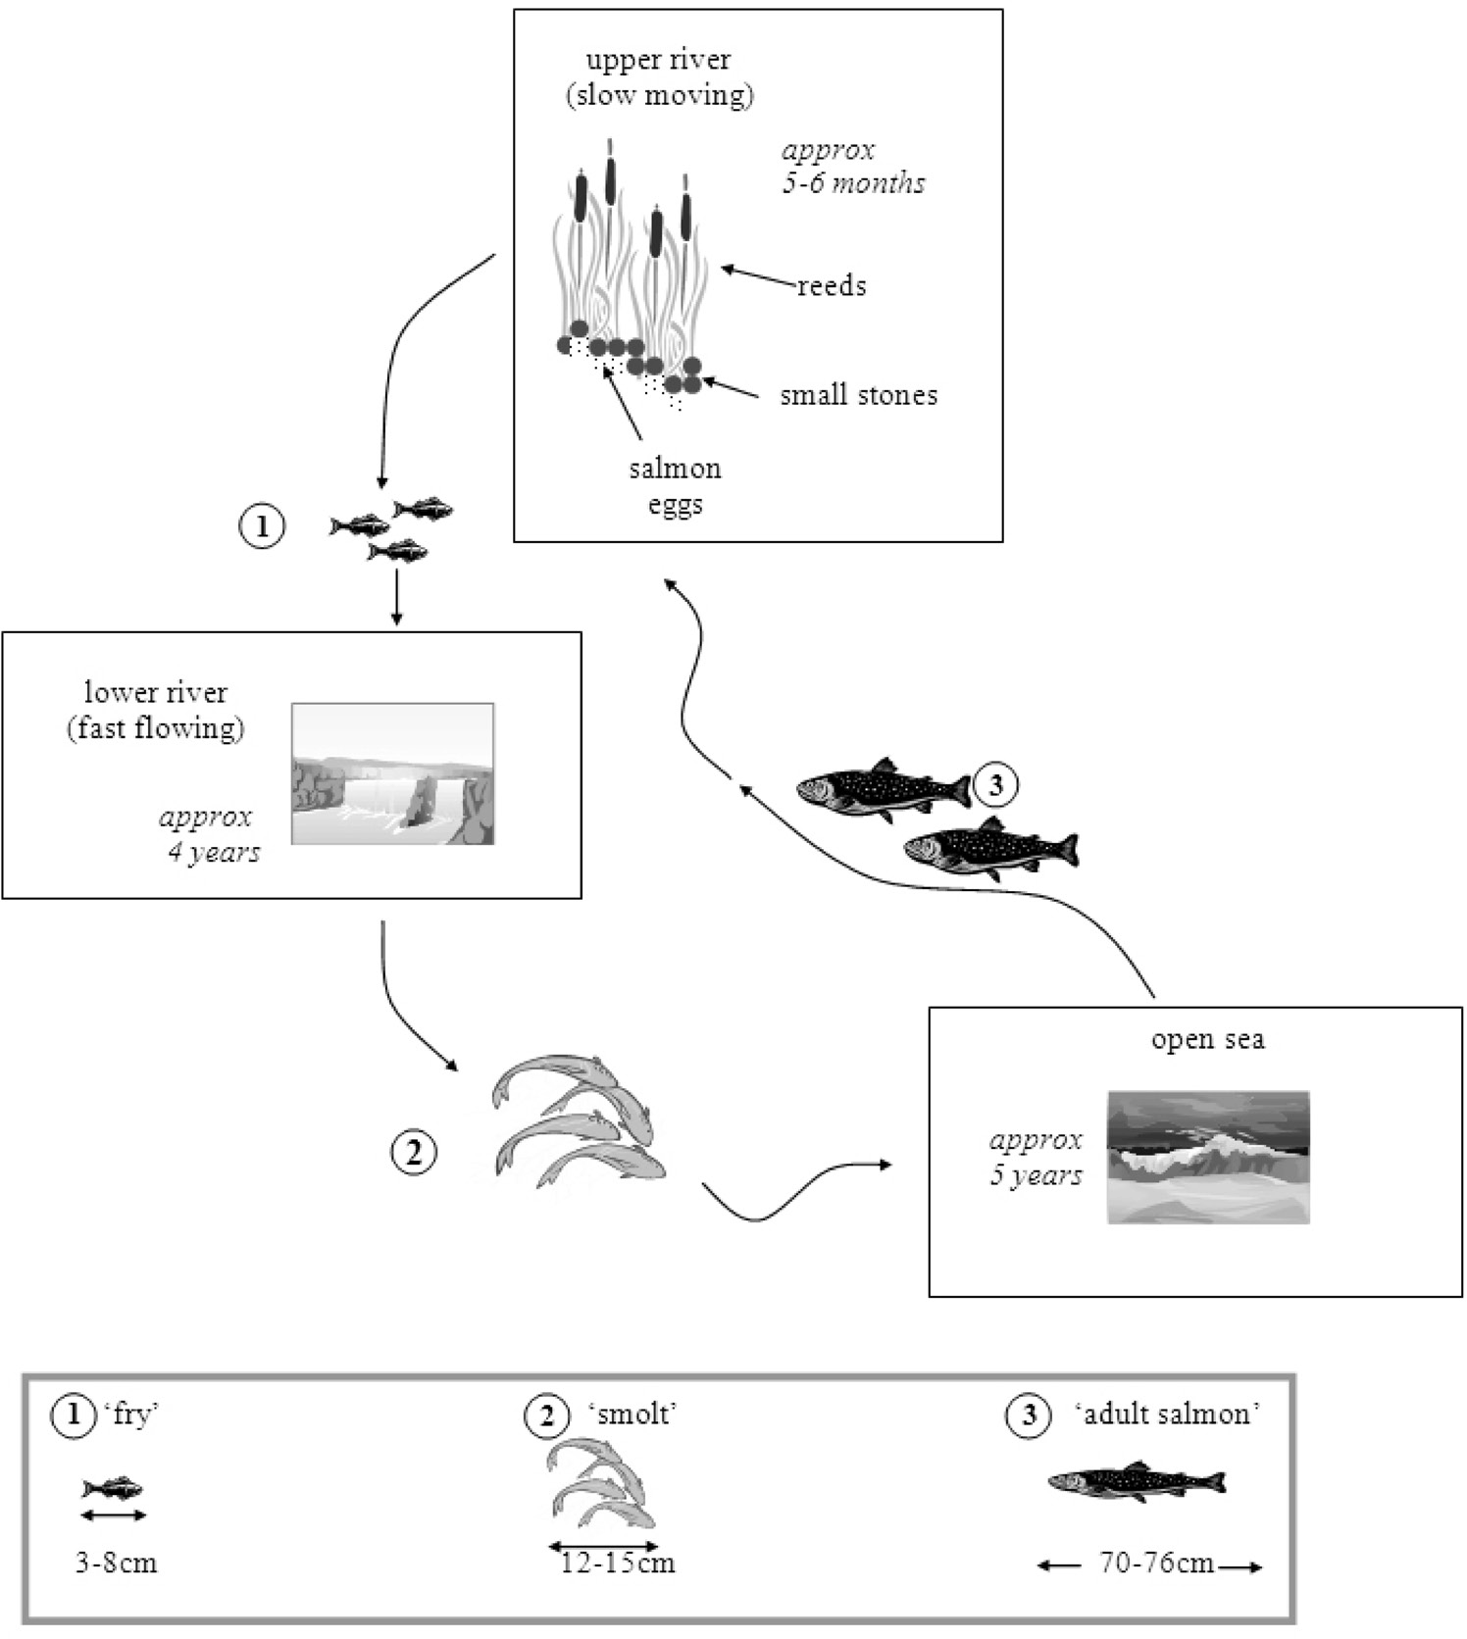
Write at least 150 words.

TEST 4, WRITING TASK 1
MODEL ANSWER

This model has been prepared by an examiner as an example of a very good answer. However, please note that this is just one example out of many possible approaches.
Salmon begin life as eggs on a pebbly riverbed, hidden among reeds in the slow- moving upper reaches of a river. After five to six months the eggs hatch into ‘fry’. For approximately the next four years, these baby salmon will live in the lower, faster-flowing waters of their river. During this time they measure between three and eight centimetres in length.

By the time salmon reach twelve to fifteen centimetres, they are termed ‘smolt’, and at this time they migrate further downriver into the open sea. After five years at sea the salmon will have grown to adult size, which is between seventy and seventy-six centimetres. They then begin swimming back to their birthplace, where they will lay their eggs, and the cycle starts anew.

In summary, the salmon passes through three distinct physical stages as it grows to maturity. Each of these stages takes place in a very different aquatic location. It is noteworthy that the first two stages of this fish’s life occur in a freshwater environment, while the third stage is lived in saltwater.

